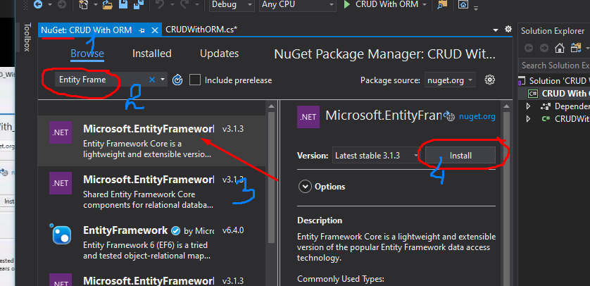**CRUD With ORM**

**Three layer model**

* Business layer = Controllers
* Data = Models
* Presentation = Views

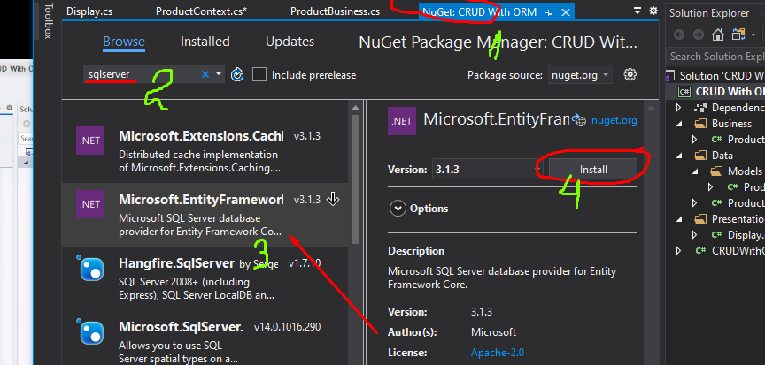**Package Manager Console**

* Install-Package Microsoft.EntityFrameworkCore.Tools
* add-migration initial
* update-database